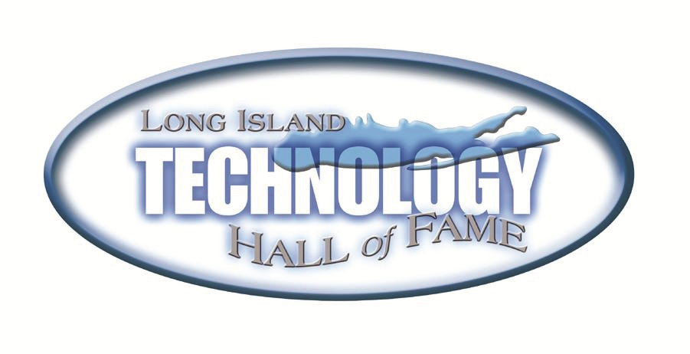

PATENT AWARD WINNERS

Innovation in Energy and Environment
8,134,281 B2 “Electrical Generators for Use in Unmoored Buoys and the Like Platform with Low-Frequency and Time-Varying Oscillatory Motions”
Inventors:Jahangir S. Rastegar, Stony Brook NY (US) and Richard T. Murray, Brentwood NY (US)
Assignee: Omnitek Partners LLC, Ronkonkoma, NY (US)

Innovation in Industry
8,231,013 B2 “Articles Comprising a Fibrous Support”
Inventors: Benjamin Chu, Setauket, NY (US), Benjamin Hsiao, Setauket, NY (US)
and Kyunghwan Yoon, East Setauket, NY (US)
Assignee: The Research Foundation of State University of New York, Albany, NY (US)

Innovation in Health and the Individual
8,109,925 B2 “Treatment of Breast Disease With Vibrating Device”
Inventors: Dan Voic, Cedar Grove, NJ (US) and Ronald R. Manna, Valley Stream, NY (US)
Assignee: Misonix Incorporated, Farmingdale NY (US)

