

AP Invoice Guide
Exceptions – Missing Invoice #, Invoice Date, Descriptions

AP Invoice User Guide – Exceptions – Invoices Missing Key Required Fields
Last Updated: 3/15/2022

Introduction: This document is an Avid site guide designed for SBF users. Here are the topics covered:
- Invoices missing required fields:
  - Cell Phones / Utility Bills……………………………………………..……………… 3-6
  - Fund Transfers…………………………………………………………………………… 7
    - Research Foundation……………………………………………………… 7
    - Among SBF Accounts (Alumni/Agency to SBF or vice-versa) 7

- Payments to SBU
  - IFR Accts – Salary / Fringe………………………………………………………….. 7
  - IFR Accts – Phone Charges…………………………………………………………. 8
  - DLAR………………………………………………………………………………………….. 9
  - Scholarships..…………………..…………………………………………………………. 10

- Miscellaneous Payments
  - Independent Contractors ……………….…………………………………………. 11
  - Memberships / Subscriptions………………………………………………………. 12
  - Awards ………………………………………………………………………………………. 13
  - Car Services……………………….……………………………………………………….. 13
  - Homeland Security ……………………………………………………………………. 13
  - Staffing – Temporary Personnel ……………………………………………….. 13
  - Property Rental………………………………………………………………………….. 13
  - Deposits for Events…………………………………………………………………….. 14
  - Deposits for Projects / Services………………………………………………….. 14
  - Payments to Small Business……….…………………………………………….… 15

- Reimbursements
  - Travel/Conference…………………………………………………………………….. 15

- SBF Only
  - Purchase Power ………………………………………………………………………… 16
  - Investment Payments………………………………………………………………… 16
  - Refunds……………………………………………………………………………………… 16

Please follow these instructions to properly fill-in the invoice date and invoice number highlighted below in red –
- Invoice Date
- Invoice Number ( NOTE – Please never use a coma in the invoice number as this creates an issue in PeopleSoft)

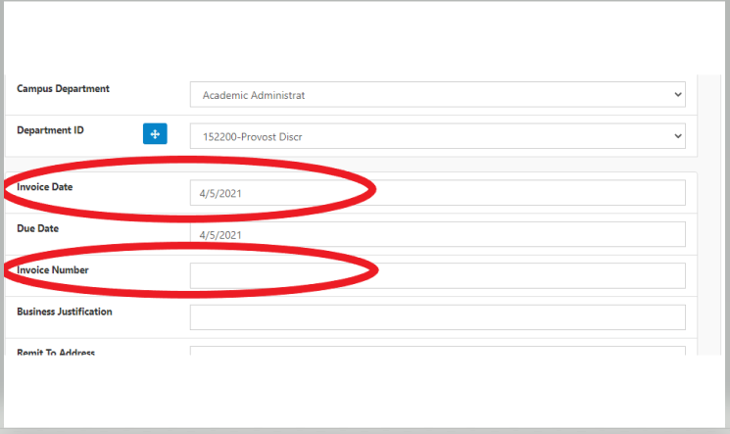

Invoice Line Description
NOTE -To be used only when there is no SBF purchase order. For invoices related to purchase orders, use the PO line number related to the invoice.

NOTE – Please never use comma’s in the description
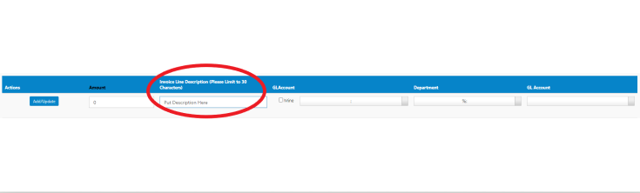

Cell Phones / Utility Bills

Verizon Wireless
- Invoice Date – Use “Bill Date”, for example 10/01/2018
- Invoice Number - NOTE - Verizon provides this on the bill
- Invoice Line Description –
  - For invoices without an SBF purchase order, this should reference the phone service and dates of service in numeric format: MM/DD-MM/DD. For example: PHONE SERVICE 09/02-10/01
  - For invoices related to purchase orders, use the SBF PO line # associated with the service period.
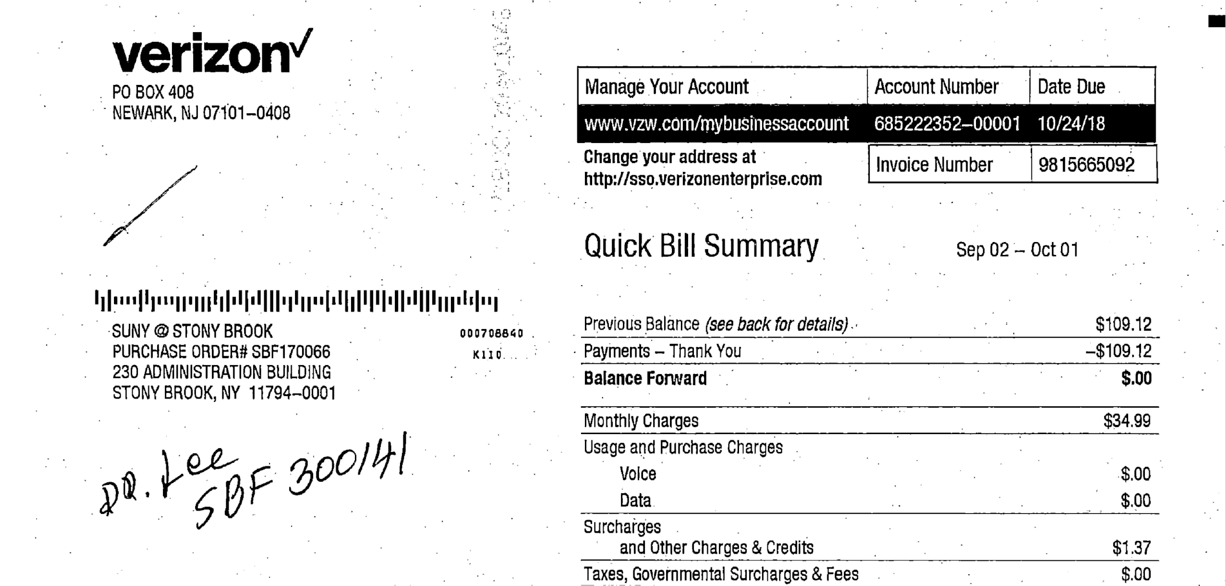
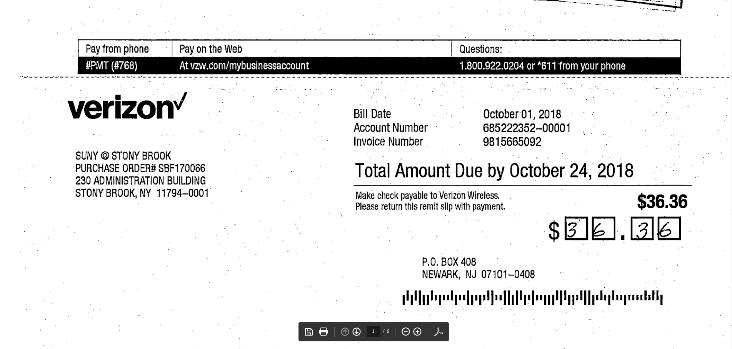

T-Mobile Bills
- Invoice Date – Use the billing date -shown here as 07/23/2020
- Invoice Number - Use the account number-underscore-billing date
For example: 945493770_7/23/20
- Invoice Line Description - For invoices without a SBF purchase order, use the word cell phone or phone and the billing period,
For example: CELLPHONE 6/23/20-7/22/20

For invoices related to purchase orders, use the SBF PO line # associated with the service period.
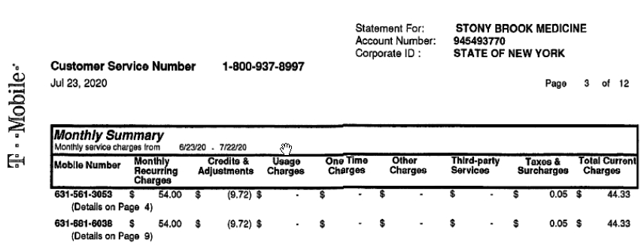

PSEG
- Invoice Date – Use the “Bill Date” just above remittance slip.
- Invoice Number - Use the “Bill Date” exactly as it appears on invoice:
For example: 10/12/2018
- Invoice Line Description – For invoices without a SBF purchase order, include location & service period: 830SPRINGS FRPL 08/11-10/11

For invoices related to purchase orders, use the SBF PO line # associated with the service period.

National Grid
- Invoice Date – Use the “Date Bill Issued”
- Invoice Number - Use “Date Bill Issued” from the invoice – use a “/” instead of the “coma” symbol
  - For example: 03/04/21
- Invoice Line Description - For invoices without an SBF purchase order, use location of service and billing period
For example: 632MAIN APTB 2/3/21-3/3/21

For invoices related to purchase orders, use the SBF PO line # associated with the service period.

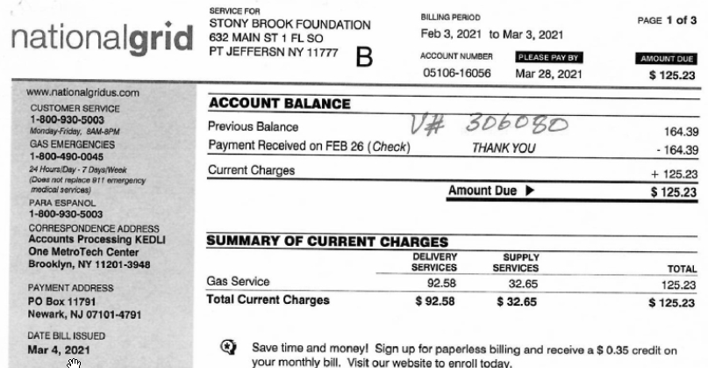
FUND TRANSFERS

Research Foundation payments Without Purchase Order (Use GL code 801451)
If no invoice number exists for the transaction:
- Invoice Date – Use the date of entry in Avid system
- Invoice Number - Use Avid AP number
- Invoice Line Description – Use “TRFR” for transfer and the RF Award #
  - For Example: TRFR 1163319-1-88997

Research Foundation Wolfmart purchase orders will not be entered by the Department.
The AP staff will enter them manually and route for approval since Purchasing Department forwards Wolfmart payment requests internally to AP.

SBF Fund Transfers to Alumni or Agency SBF Accounts and vice-versa
- Invoice Date – Use the date of entry in Avid system
- Invoice Number - Use Avid AP number
- Invoice Line Description – Type the appropriate payment description for this type of transaction (only 30 characters.)

PAYMENTS TO STONY BROOK UNIVERSITY

Stony Brook University - Salary and/or Fringe Reimbursements to IFR accounts
- Invoice Date – Use the date of entry in Avid system
- Invoice Number - Use Avid AP number
- Invoice Line Description – For payments without a purchase order, use the IFR number to which the funds will be transferred. For example: “SLRY IFR# first-initial last-name” or quarter number if appropriate. For example:
  - SLRY IFR###### S.STANLEY or SLRY IFR###### Q4 S.STANLEY
  - FRNG IFR###### S.STANLEY or FRNG IFR###### Q4 S.STANLEY

If the salary and/or fringe reimbursement pertains to a Purchase Order,
- Invoice Date – Use the date of entry in Avid system
- Invoice Number – Use the SBF PO# and the Avid entry date
  - For example: SBF310753_4/24/19
Invoice Line Description - Use the SBF PO line # associated with the payment.

IFR Monthly Phone Charges
- Invoice Date – Use the billing date, For example: 04/21/18

- Invoice Number - Use SBF department account number (circled in red below)-underscore-billing date in DD.MON.YYYY format:
  - For example: 298650_21.APR.2018

- Invoice Line Description- For payments without a purchase order, Description will contain the words referencing phone service. For example: PHN SVC TELNET MAR 2018 or TELNET PHONE MAR 2018

Invoice Line Description for payments related to a purchase order, use the SBF PO line # associated with the payment.

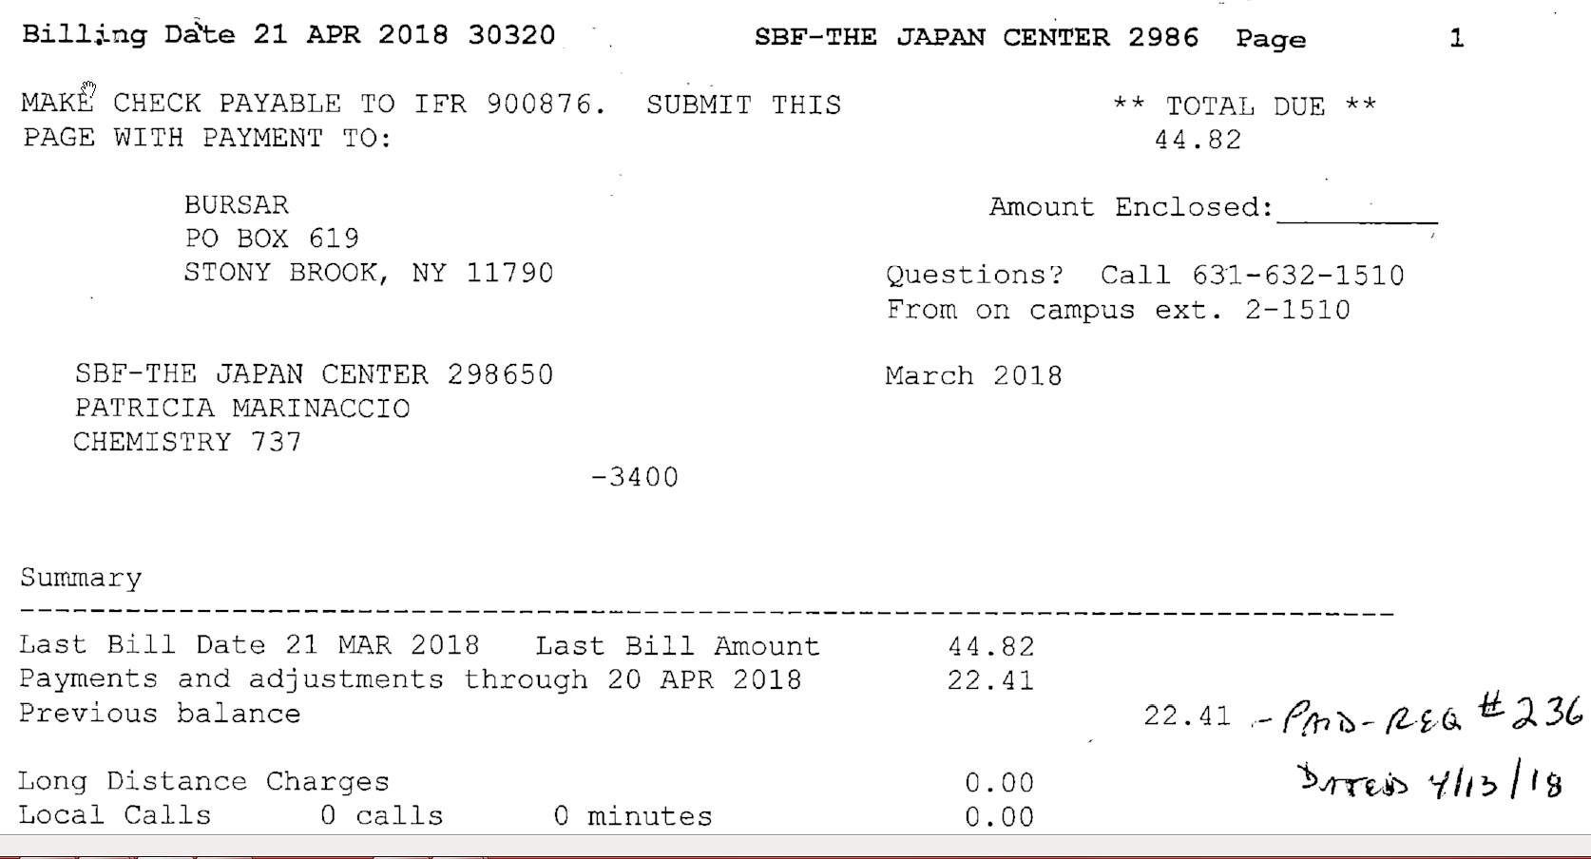

DLAR (For Laboratory Animal Resources) Use GL CODE 823330 for Lab Supplies
- Invoice date – Use the last date of the time period, for example: 12/31/2020 as shown below
- Invoice Number - NOTE – This is provided on the bill
- Invoice Line Description – Use: “LAB SUPP RAT RESEARCH” or “LAB SUPP MOUSE RESEARCH”

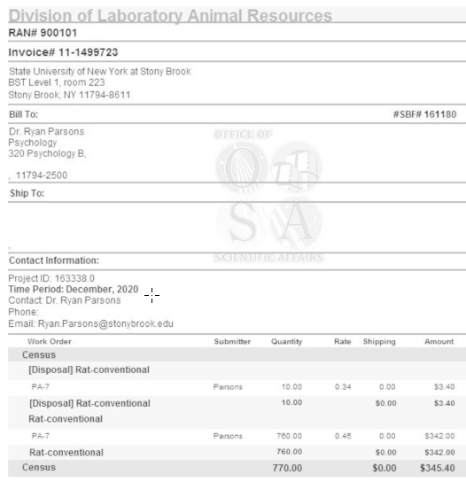

Stony Brook University - Scholarships (Payments made to SBU Student Accounts via Bursar for scholarships to students.)

- Invoice Date – Use the date of entry in Avid system
- Invoice Number - Use Avid AP number
- Invoice Line Description:
  - For medical school students, it will contain " MED SCHOL"_Student ID_Semester _Year. For example:
    - MED SCHOL_111688388_Fall_2018
    - MED SCHOL_111688388_ SPRNG 2019
    - MED SCHOL_111688388_SUMM_ 2019
    - MED SCHOL_11688388_WINT_2019
  - Description for non-medical scholarships – It shall contain SCHOL_Student ID_Fall (or Spring)_Year For example:
    - SCHOL_111688388_FALL_2020
    - SCHOL_111688388_SPRING_2021
    - SCHOL_111688388_FALL20/SPRNG21

Miscellaneous Payments

PAYMENTS TO INDEPENDENT CONTRACTORS
- Invoice Date – Use the beginning date of service (“from” date)
- Invoice Number – Use IC Form number if no invoice number is provided (found in upper-right corner, shown here as: 200317-95701)
- Invoice Line Description:
  - For Speakers (GL code 808701), will contain the words “HONORARIUM”
  - For Professional Services (GL code 814401), will contain the words “PROF SVC” and the type of service, for example: “PROF SVC-WRITING”
  - For Entertainment Services (GL code 805001), will contain the words “ENTERTAINMENT” and the type of service, for example: “ENTERTAINMENT-MUSIC-2/25/20”

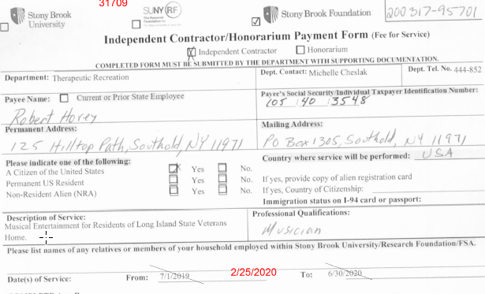

Memberships & Dues (GL code 823202) and Subscriptions (GL code 823201)
- Invoice Date – Use the date of entry in Avid system
- Invoice Number - Use Avid AP number
- Invoice Line Description - Will contain the word Membership, Dues or Subscription and the period. For example:
  - MEMBERSHIP 09/01/20-08/31/21 (example below) or
  - MBRSP 1/1-12/31/17 STANLEY or
  - SUBSC 7/1/20-6/30/21 STANLEY
If there is no period, please use current year (for example, SUBSC STANLEY 2021)

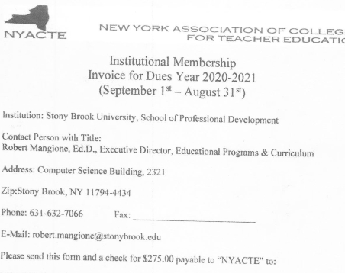

Awards (payments to individuals)
- Invoice Date – Use date of entry into Avid system
- Invoice Number - Use Avid AP number
- Business Justification – In this section include
  - “As per the selection committee’s review, (student’s name) best meets the prize or award criteria.”
  - Recipient’s Solar ID / Semester and Award Year
- Invoice Line Description In this section include the name of the Award
  - For example: “SKLAR PRIZE” or “GRADUATE TEACHING AWARD”

Payment for Car Services
- Invoice Date – Use the first date of travel
- Invoice Number - Use trip # or confirmation # as invoice number (If none, use Avid Transaction number)
- Invoice Line Description - Description will contain “TVL”, the purpose for trip and first initial. Last name.
  - For example: TVL-SPEAKER S.STANLEY or TVL-MTG M.MCKINNIS

Homeland Security
NOTE - If separate checks are needed, enter each amount in a separate Avid transaction.
- Invoice Date – Use date of entry into Avid system
- Invoice Number – Use Avid AP number
- Invoice Line Description - Will contain the recipient ‘s name
For example: FILING FEE H-1 S. STANLEY)

Staffing Companies for Temporary Personnel
- Invoice Line Description – Always put “SALARY” and Person’s name and ending pay cycle date
  - For example: SALARY M.THOMAS 12/31/20

Property Rental (Must be connected to an SBF purchase order)
- Invoice Date – Use date of entry into Avid system
- Invoice Number - Use SBF PO# - underscore - 3-letter month - 4-digit year,
  - For example: SBF510444A_APR2021
- Invoice Line Description – Use the SBF PO line # associated with the rental period.

Deposit for Events (Must be connected to an SBF purchase order)

- Invoice Date – Use the date of entry into Avid system
- Invoice Number - Use the word “Deposit”-underscore-event date
  - For example, DEPOSIT_02/11/2021
- Invoice Line Description - Use the SBF PO line # associated with the payment.

- For the rare exception where a deposit needs to be sent while the purchase order is not yet completed
- Invoice Date – Use the date the agreement was signed
- Invoice Number – Use the Avid AP Number
- Invoice Line Description - Will contain the word “Deposit” (or abbreviation DEP.) and name of event or purpose for deposit. Agreement must be attached in Avid.
  - For example: DEPOSIT QUANTUM WKSHP or DEPOSIT 5/22/21 GALA

Deposit for Projects, Services or Retainers with no specific date of event (Must be connected to a SBF purchase order)

- Invoice Date – Use the date of entry in Avid system
- Invoice Number - Use the word “Deposit”-underscore-SBF PO#
  - For example: DEPOSIT_SBF510500
Invoice Line Description - Use the SBF PO line # associated with the payment.

Investment Payments (SBF only)
- Invoice Date – Use the date of entry in Avid system
- Invoice Number - Use Avid AP number
- Invoice Line Description: Type the appropriate payment description for this type of transaction (only 30 characters.)

Payment for Small Business (Mom-and-pop)
- Invoice Date – Use the date of entry in Avid system
- Invoice Number - Use Avid AP number
- Invoice Line Description: Type the appropriate payment description for this type of transaction (only 30 characters.)

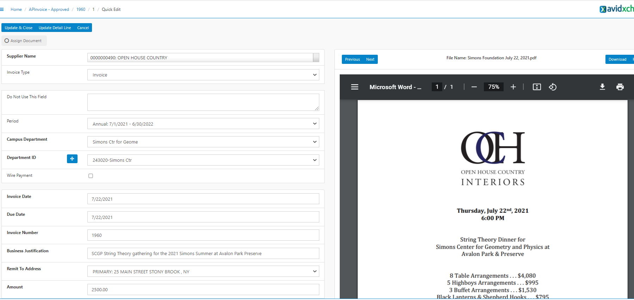

Reimbursements - (Only for outside individuals and SBU Student)
- Invoice Date – First date of travel
- Invoice Number - Use Avid AP number
- Invoice Line Description: Type the appropriate payment description for this type of transaction (only 30 characters.). You may need to add multiple lines to detail the receipts.

Payment for Purchase Power (SBF only)
- Invoice Date – Statement Date
- Invoice Number – Use Avid AP number
- Invoice Line Description: Type the appropriate payment description for this type of transaction (only 30 characters.)

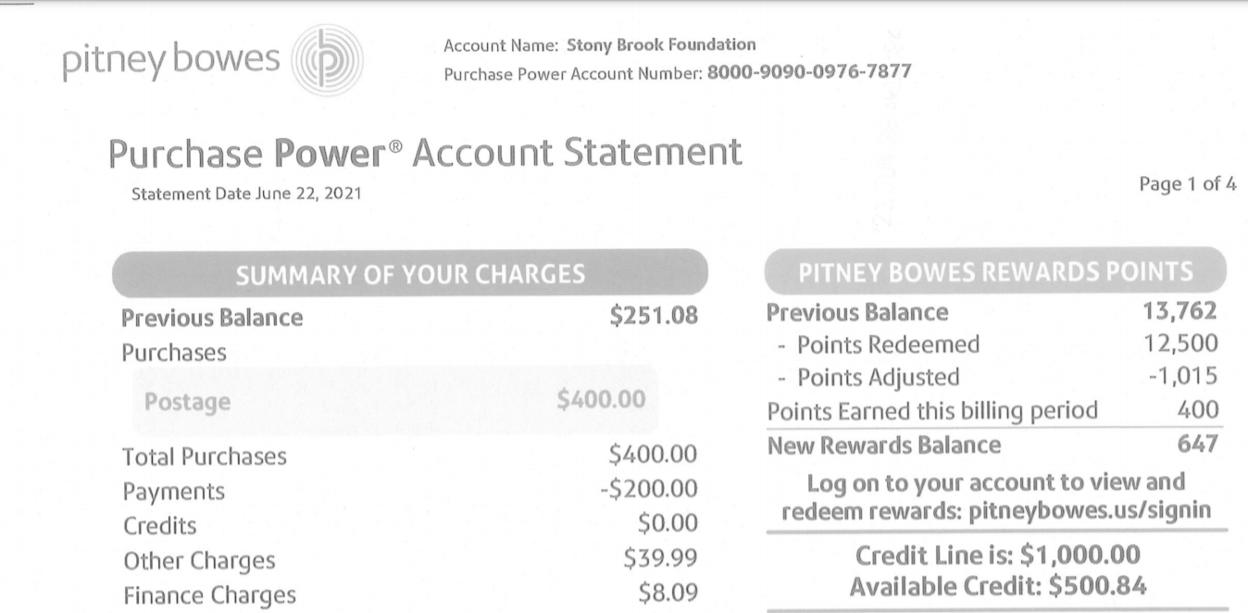

Refunds (SBF only)
- Invoice Date – Use the date of entry in Avid system
- Invoice Number - Use Avid AP number
- Invoice Line Description: Type the appropriate payment description for this type of transaction (only 30 characters.)

Investment Payments (SBF only)
- Invoice Date – Use the date of entry in Avid system
- Invoice Number - Use Avid AP number
- Invoice Line Description: Type the appropriate payment description for this type of transaction (only 30 characters.)

